**Приложение 5**

Министерство образования и науки Республики Казахстан

Astana IT University

ОТЧЕТ

О выполнении программы производственной практики

База практики: TOO “STN Technologies”

Студент: Садық Әділет Нұрғисаұлы

Образовательная программа: B057 Информационные технологии

Группа: SE-2102

Руководители практики: Айтмұханбетова Эльвира

**Содержание**

Задание на практику 3

Введение 3

Основная часть 4

Теоретическая часть 4

Практическая часть 7

Заключение 8

Список литературы 8

### Задание на практику

The main purpose of the internship is to consolidate the skills and abilities obtained in the study of various disciplines during the study at the university.

The main tasks during the practice are instilling a culture of work at the enterprise, developing the ability to independently creatively use the acquired knowledge in the conditions of a particular enterprise.

During the internship at the enterprise, it is necessary to get acquainted with the activities of the enterprise, the job descriptions and safety precautions at the workplace, hardware and software, perform an individual task in accordance with the program and provide reporting documentation.

This practice was held in the TOO “STN Technologies”from March 6, 2023 to April 1, 2023 as a specialist in the information technology department.

### Введение

TOO “STN” Technologies-leading electronics distributor in Kazakhstan.

Working through the line of Consumer (retail) distribution, we supply equipment to our Partners - companies operating in IT retail. Each of our clients, starting from the smallest, gets the opportunity to participate in all affiliate programs aimed at stimulating sales. We care about the profitability of your business. No matter how big your Company and business is, you will receive a product and conditions that will allow you to earn.

If you work in retail IT, or are planning to start a business in this area, but are not yet our partner, give us a call. We do not work in Retail, so we will not compete with you. On the contrary, we, knowing everything about this business, will help your Company to be even more successful.

Another part of our work is Corporate (project) distribution. We are open to our Partners - Companies working with corporate clients in the field of system integration, involved in installations, as well as companies whose business is related to participation in competitions, tenders for the purchase of IT and telecommunications equipment. Keeping the principle of classical distribution, we do not participate in tenders, we do not go out with commercial offers to the end customer.

Understanding the importance of the safety of commercial information, we guarantee the confidentiality and protection of the Partner's projects on which we work together. We are ready to provide consulting support and assistance in choosing a solution for the project. Distributor status and close relationship with the equipment manufacturer allows us to provide special project prices. We give the correct terms of delivery of equipment and are responsible for their implementation.

The internship student has the following responsibilities:

- checking computers for information security

- checking company software for errors

- work with the company database

- diagnostics of all computers and equipment of the company and checking for operability

### 

### Основная часть

### Теоретическая часть

The company has implemented and operates information systems 1c, excel and word is an information system designed to automate business processes and

The main software products used in the Department are: Microsoft Word, Microsoft Excel, Avast Antivirus, 1C for Enterprise. All programs are linked to each other since applications are processed and saved in the specified programs. To draw up a contract and draw up a condition, Microsoft Word is used. Microsoft Excel is used to save applications and data for ordering. 1C for an enterprise is an accounting program used in many companies; a database with product catalogs is stored here and the entire working system goes through this system.

**1C:Enterprise - effective management, accounting and document flow in more than 1,500,000 organization.** **The 1C:Enterprise technological platform is a software shell over the database. Databases based on DBF files in 7.7, native 1CD format from version 8.0 or Microsoft SQL Server DBMS on any of these versions are used. In addition, since version 8.1, data storage is possible in PostgreSQL and IBM DB2, and since version 8.2, Oracle has also been added. The platform has its own internal programming language, which provides, in addition to data access, the ability to interact with other programs via OLE and DDE, in versions 7.7, 8.0 and 8.1 - using a COM connection.**

**The client part of the platform operates under Microsoft Windows, and starting from version 8.3, also under Linux and macOS. Starting from version 8.1, the server part of the platform in the client-server version of 1C:Enterprise can operate on Microsoft Windows and Linux operating systems.**

**There are special versions of the 1C runtime environment for laptops and PDAs, software for creating web applications that interact with the 1C:Enterprise database.**

Possibilities of general settings of the program (such as setting the date of prohibition of data editing);

Possibilities of individual program settings for each user (such as the main warehouse for automatic substitution in documents);

Many switchable interfaces;

Many sets of rights (roles), and some of the rights can be assigned by users in the enterprise mode;

More flexible customizable reports than in version 7.7;

Ability to build custom reports (the so-called "Reports Console");

Built-in universal data exchange;

Built-in Internet Updates

**Microsoft Excel (also sometimes referred to as Microsoft Office Excel) is a spreadsheet program created by Microsoft for Microsoft Windows, Windows NT, and Mac OS, as well as Android, iOS, and Windows Phone. It provides economic and statistical calculations, graphical tools, and, with the exception of Excel 2008 under Mac OS X, the VBA (Visual Basic for Application) macro programming language. Microsoft Excel is part of Microsoft Office.** The API allows you to open Excel spreadsheets in a number of other applications. This includes opening Excel documents on web pages using ActiveX or plugins such as Adobe Flash Player. The Apache POI project introduces Java libraries for reading and writing Excel spreadsheets. There have also been attempts to copy Excel spreadsheets to web applications using comma-separated values (CSV).A valuable feature of Excel is the ability to write code based on Visual Basic for Applications (VBA). This code is written using a separate editor from tables. The spreadsheet is managed through an object-oriented code and data model. With this code, the data of the input tables will be instantly processed and displayed in tables and charts (graphs). The table becomes the interface of the code, making it easy to work with, modify it, and manage calculations.

### Практическая часть

In this photo you can see the portfolio of the company this is just a small part of all the company.

My workplace was in IT (Software Engineer), in the first week I had an acquaintance with the place of work and its rules. On the first day, employees held a mini tour of the workplace. Impressions were only positive. He quickly got used to the workplace and found a common language with the team. After that, I started working from a warehouse where I needed to check the equipment, that is, printers, keyboards, mice, and of course computers. In this part, everything was easy thanks to the knowledge gained during the course of computer architecture, because in this course we went through everything in practice, that is, in laboratory practices.

The next week, according to the plan, I had the task of checking the hardware and software for errors and, if possible, fixing them. The company is equipped with new techniques and equipment, but despite this, diagnostic procedures are carried out in a timely manner, since the company is an IT company that understands the importance of every detail and tries to take care of everything. Still, I found some defects in computers and printers. There was a moment when I could not understand the problem of one printer, thanks to a friendly team, they helped me solve this problem.

Working with the company's database was to fill out applications from different companies, firms for the provision of IT services. Our company guarantees the confidentiality of all trading activities of its partners, therefore, work with databases and applications are not disclosed. But in this part of knowledge from the subjects of advanced database, backend, they helped me solve problems without any problems. There was also work with databases related to employees where I needed to update the list of employees, if necessary, change personal data such as address, phone number, etc. Since the company is a distributor, we prepared computers and equipment according to factory settings, and also, at the request of the client, add Microsoft office and antivirus so that clients can start working immediately.

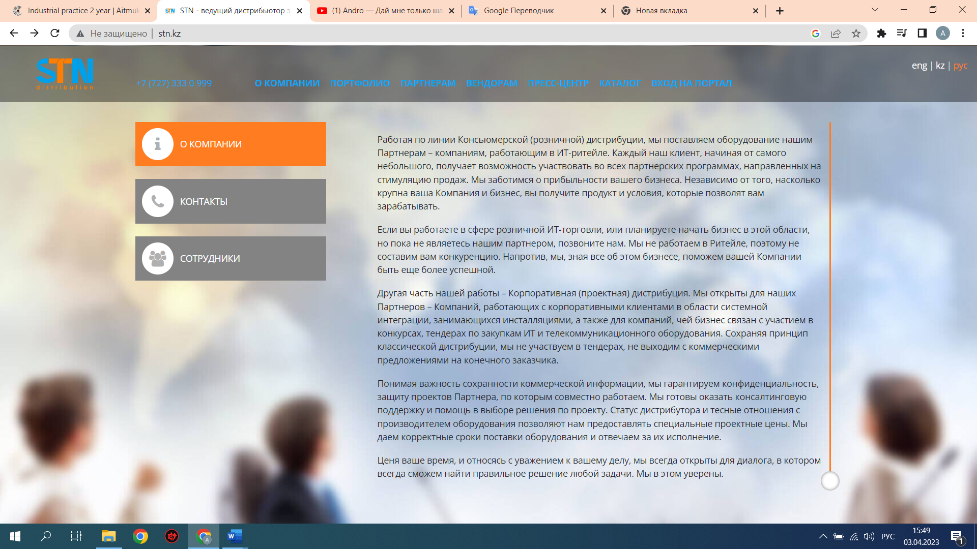

During the internship, I noticed some advantages and disadvantages in the work of the company. The first thing I would like to note is that the security system and the information security policy in general are very highly developed here. The company guarantees confidentiality between its partners and clients. Appeals and orders are processed online, all technical problems can be solved remotely. The entire system undergoes scheduled diagnostics and conducts a thorough check of everything. The company observes working conditions for employees and can also put discipline and compliance with the internal policy of the company in the first place. A huge plus is the friendly young team that brings together the best of the best in their field.

### I would recommend the company to upgrade the computers and their accessories like mice, webcams and headphones, as the old ones are largely out of order and need to be replaced.

### Заключение

### I strengthened my academic study skills with practical ones during the internship. I became familiar with the Department's framework, organization, and operating principles. Enhanced speaking abilities. gained knowledge of group collaboration. He demonstrated during the job that he was a competent and trustworthy worker.

### He promptly finished the duties that were given to him. The individual job that was given to the company was finished entirely and on time. He broadened his understanding of information systems, antivirus software, computer networks, etc. during his internship. The ability to use personal computer software effectively and solve real issues on one's own was acquired after practice, which allowed for the systematization of theoretical knowledge. consolidate the knowledge, skills, and abilities acquired up until that point while pursuing your studies at the institution.

### I believe that I must continue to increase my understanding of software and software programming. The information learned while studying topics like web front-end development, database management systems, algorithm and data structures, and others proved to be particularly useful during the job.

### I believe that the month I spent practicing was worthwhile, and I am hoping that the job experience will be helpful in the future.

### Список литературы

* <https://ru.wikipedia.org>
* <http://www.stn.kz/>